Searching for AR levelled books in MyOn Reader
Step 1: Sign into MyOn Reader (Username: primary or secondary Password: books)

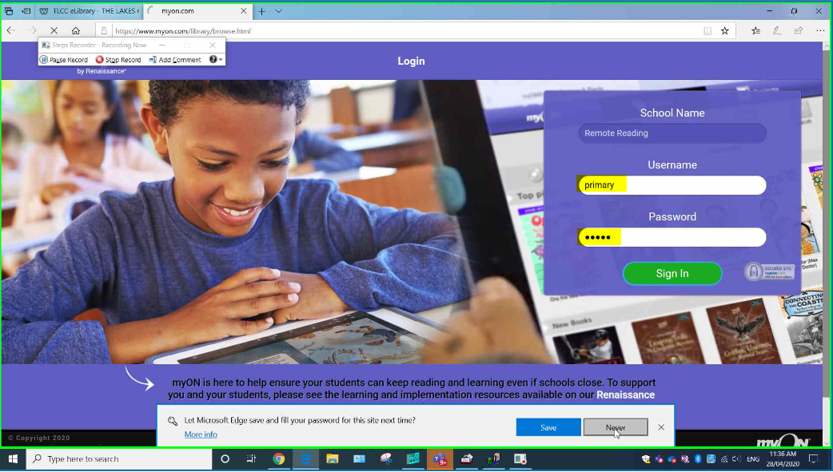

Step 2: Click on ‘Search’

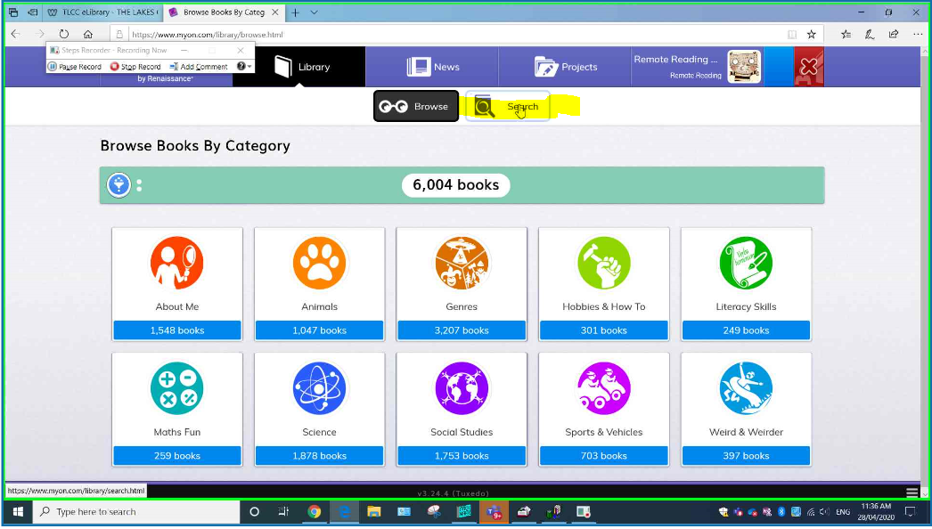

Step 3: Click the filter icon highlighted in yellow below.

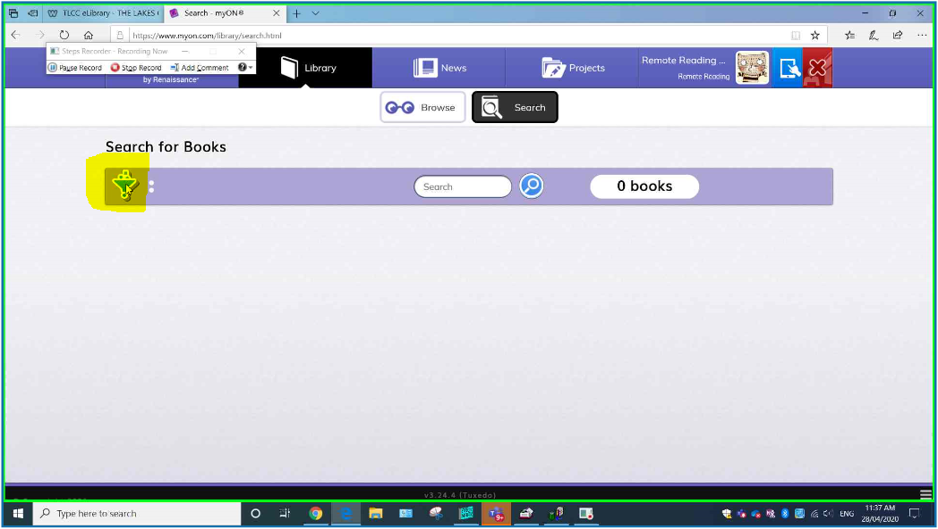

Step 4: Click on ‘ATOS’ (ATOS = AR book level)

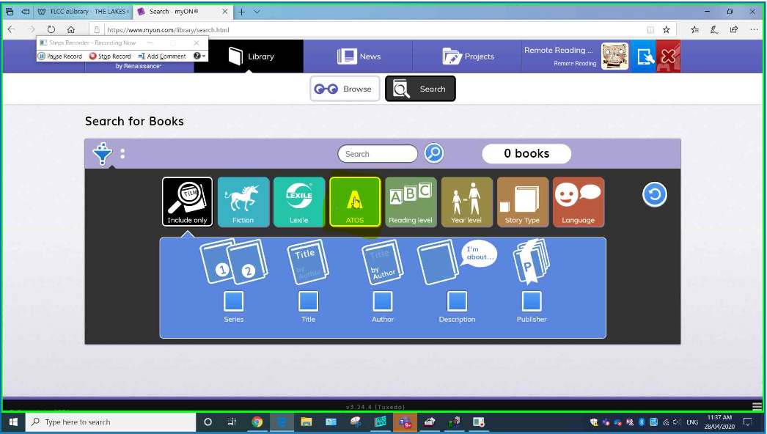

Step 5: Select your reading level.

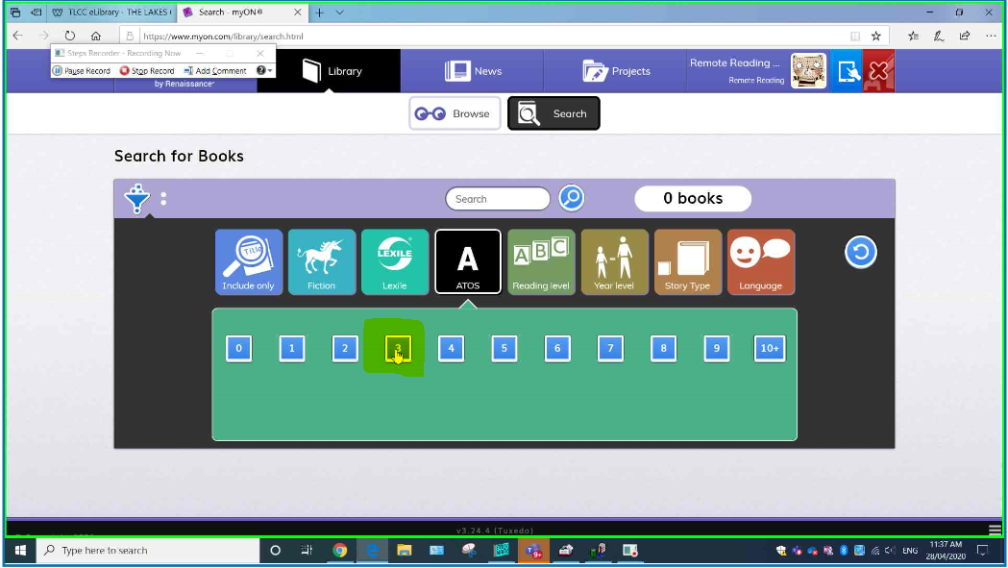

Step 6: Click the ‘Search’ icon.

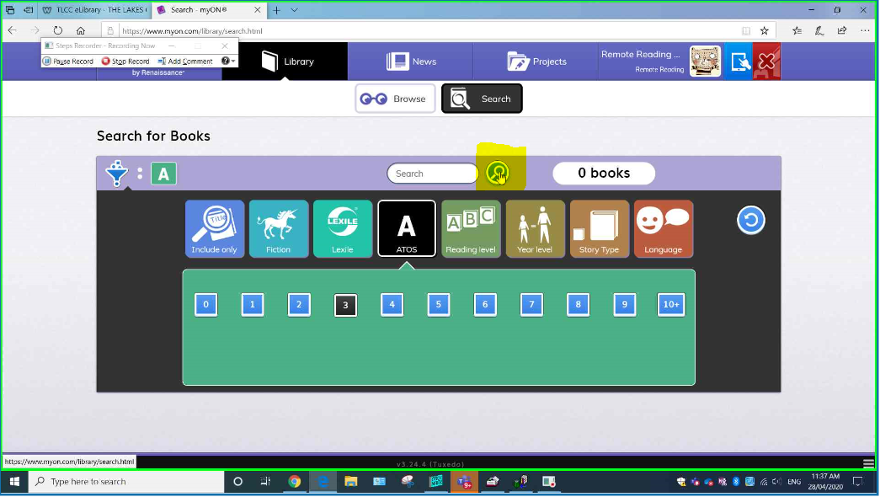

Step 7: Scroll below to browse ebooks.

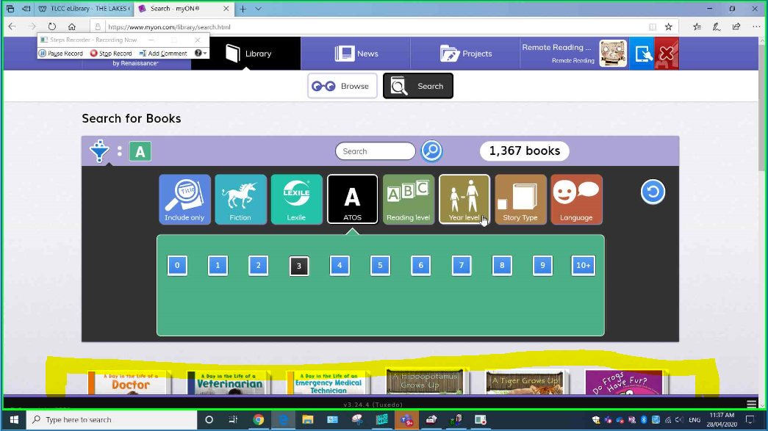

Step 8: Select an ebook of interest and click ‘Info’ to see its reading level.

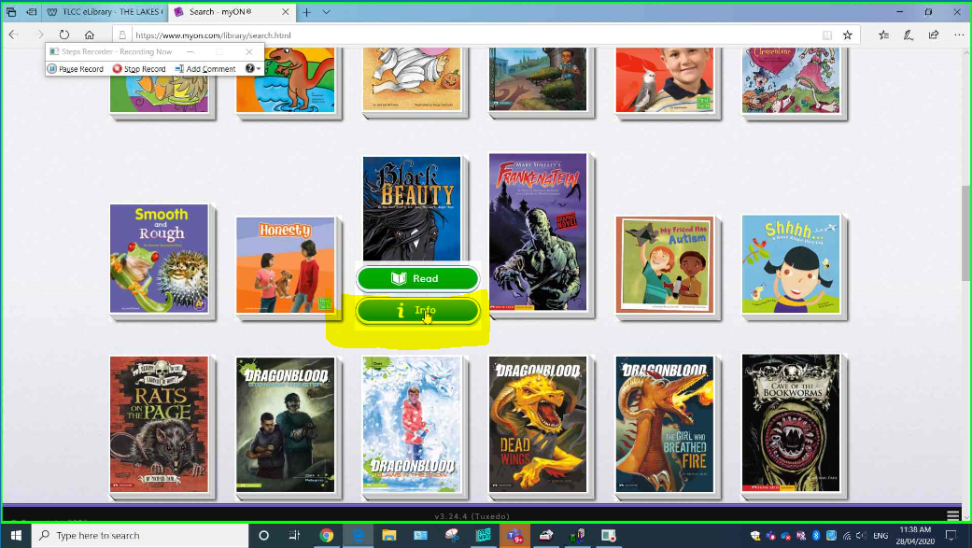

Step 9: Click ‘Details’

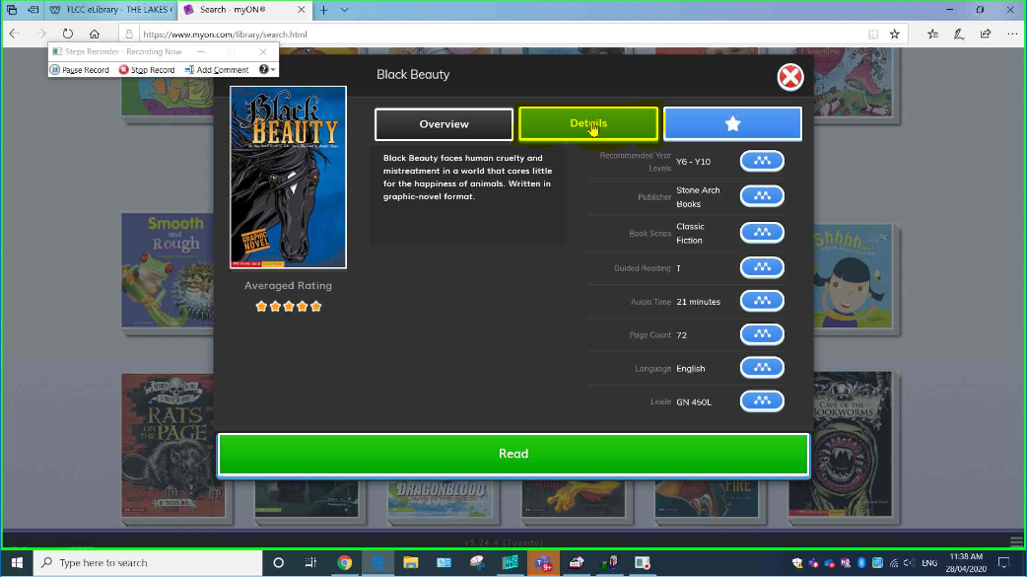

Step 10: The ‘ATOS’ is the ebook’s AR reading level.

